|  |  |
| --- | --- |
| Map  Description automatically generated  Human Rights Violations by Azerbaijan in the Time of Blockade | Text  Description automatically generated  The present report is a reference to the humanitarian consequences of the blockade of the only road connecting Nagorno-Karabakh to the outside world. The report also analyses the situation from the legal perspective, as the blockade caused violation of a long list of human rights and fundamental freedoms.  JOINT REPORT of NGOs |

**Stepanakert**

**January 2023**

**Table of Contents**

**Acronyms and Abbreviations** 2

**1. Chronology- Statement of Facts** 3

**2. Violation of Human Rights Law** 6

**Freedom of Movement** 6

**The Right to Freedom from Discrimination** 10

**Right of Everyone to an Adequate Standard of Living for Himself and his Family, including Adequate Food, Clothing and Housing, and to the Continuous Improvement of Living Conditions** 14

**Right to Medical Care** 18

**Rights of the Child** 20

**Right to Education** 23

**The Right to Family and Private Life** 24

**3. Siege of Nagorno-Karabakh under International Humanitarian Law** 26

**CALL TO THE INTERNATIONAL COMMUNITY** 29

**List of NGOs:** 30

# **Acronyms and Abbreviations**

1. **API** - Protocol Additional to the Geneva Conventions of 12 August 1949, and Relating to the Protection of Victims of International Armed Conflicts (Protocol I)
2. **ATMs**- Automated Teller Machines
3. **CEDAW**- International Convention on the Elimination of All Forms of Discrimination Against Women
4. **CJSC** - Closed Joint Stock Company
5. **CRC** - Convention on the Rights of the Child
6. **CRPD** - Convention on the Rights of Persons with Disabilities
7. **ECHR**- European Convention on Human Rights and Fundamental Freedoms
8. **GCIV**- The Geneva Convention Relative to the Protection of Civilian Persons in Time of War (IV Geneva Convention)
9. **ICCPR**- International Covenant on Civil and Political Rights
10. **ICERD**- International Convention on the Elimination of All Forms of Racial Discrimination
11. **ICESCR**- International Covenant on Economic, Social and Cultural Rights
12. **CESCR** - The Committee on Economic, Social and Cultural Rights
13. **ICRC**- International Committee of the Red Cross
14. **IDP**-Internally Displaced Person
15. **MIT**- National Intelligence Organisation
16. **NK**- Nagorno-Karabakh
17. **UDHR**-Universal Declaration of Human Rights
18. **UN**- United Nations

# **1. Chronology- Statement of Facts**

* On 12 December 2022, Azerbaijan arranged through so- called “eco activists” the blockade of the only road connecting the 120,000 people- ethnic Armenians in Nagorno-Karabakh with the outside world, thereby preventing anyone and anything from entering or exiting[1] and leaving thousands of families and children on different sides of the closed road (further discussed in the report with concrete figures).

The 120,000 ethnic Armenians in Nagorno-Karabakh are now entirely encircled by Azerbaijan, completely cut off from access to the outside world. Genocide Watch, after having issued a “genocide warning” in September 2022[2] —an alert reserved for situations where “the genocidal process has reached the stages of preparation by perpetrators and persecution of a targeted group”[3]—has declared that “[t]he 120,000 Armenian Christian residents of Nagorno-Karabakh are now effectively under siege”.[4]

* On 13 December – the gas supply was cut by Azerbaijan, given the fact that the only pipeline supply Nagorno-Karabakh with gas comes from Armenia through the Lachin corridor and in some parts, it passes through the territories under control of Azerbaijan. The latter uses every occasion to cut the population and put pressure on Nagorno-Karabakh through ‘gas manipulations’.
* On 14 December because of the scarcity of fuel, limitations on their sale were imposed by the authorities of Nagorno-Karabakh causing additional problems with freedom of movement even inside NK.
* On 16 December due to pressure from international community, the gas supply was restored.
* On 17 December protests commenced in front of the United Nations office in Armenia demanding to take action to open the road.
* On 19 December, only on the 8th day of the blockade, only after extensive volume of negotiations first time International Committee of the Red Cross (ICRC) was able to transfer a person in a critical medical condition to a medical facility in the capital of Armenia, Yerevan. Meanwhile, one of the patients Azerbaijan did not give consent to transfer already died in a hospital. According to Mher Musaelyan, the executive director of the Republican Medical Centre, the patient had been on haemodialysis for 15 years and needed further examination which he could not undertake because of the closure of the only road to Armenia [5].
* On 20 December, United Nations Security Council discussed the issue of closure of Lachin Corridor in extraordinary session.
* On 23 December, the residents of Nagorno-Karabakh marched towards the place of closure of the corridor but were not able to proceed farther because of Russian Peacekeeping Contingent.
* On 24 December the ICRC was able to transfer only one patient from Stepanakert to Yerevan, a 4-month-old child with the diagnosis of "intestinal leishmaniasis" was in a critical condition for days and under the supervision of local doctors.
* On 25 December about 50 thousand citizens participated in a rally in the Renaissance Square of Stepanakert and the NK National Assembly confirmed the will of the NK population to control its destiny [6].
* On 26December a group of volunteers from Armenia with an initiative to support the children of Nagorno-Karabakh and provide them with Christmas gifts attempted to enter the territory of Nagorno-Karabakh and pass the corridor, however, was stopped on the border area of Armenia[7].
* On 28 December a protest demanding to use the influence and open the road took place in front the base of Russian Peacekeeping Contingent.
* On 29 December, essential commodities were already out of stock, causing humanitarian consequences. Majority of shops became empty with occasional delivery of dairy products being exhausted momentarily. The situation gets dire in subsequent days.
* On 6 January a resident of Hatsi village of the Martuni region I. Abrahamyan contacted the police and reported that around 1 PM, while doing agricultural works with the "Belarus 82-1" tractor operated by him in the area called "Kaghnun tak” (“Under the Oak") of the administrative area of ​​Hatsi village, a round of fire was directed towards his tractor from the adjacent Azerbaijani combat position. Agricultural works have been suspended.
* On 8 January, the Ministry of Education, Science, Sports and Culture of NK announced that due to the issues caused by the electricity cut, as well as the scarcity of caused by the blockade of the road the kindergartens as well as preschools and schools working with extended hours will remain closed [8].
* On 9 January, because of the accident occurred on the 33rd km of the only Goris-Stepanakert 110 kV high-voltage line feeding NK from Armenia NK became deprived from the electricity. According to the employee of the electricity company, the data recorded by the equipment shows that the accident occurred in the Aghavno-Berdzor section of the line[9]. Due to the destructive position of the Azerbaijani side, it has been impossible to organize emergency restoration works in the mentioned section, so a decision was made to supply electricity through local generating stations with appropriate restrictions. Based on the situation, rolling blackout is being implemented in NK starting as of 10 January [10].
* On 10 January the President of Azerbaijan in his interview with local media channels in relation to Armenians of Nagorno-Karabakh stated that: “Whoever does not want to become a citizen of our country, the road is not closed, they can leave. Nobody will interfere. They can leave in the cargo compartment of peacekeepers’ trucks, on buses. The road is open”[11].
* On 12 January the internet cable coming from Armenia to NK and providing fixed internet to the population was damaged and the staff of the communication company was not able to reach to the damaged area to conduct repair works. Only after more than 24 hours, due to the negotiation efforts of Russian Peacekeeping Contingent the company employees were able to travel to the area in Lachin corridor where damage was caused in unknown circumstances.
* On 13 January a ration stamp/ coupon system was introduced by the NK government, which will allow for the distribution of certain foodstuffs proportionately. The ration cards/coupons will be used to buy only essential products, such as sunflower oil (1 litre per person), rice, sugar, buckwheat, and pasta (1 kg per person per month). The coupons will be usable by 20 January [12].
* On 16 January it was announced that due to electricity shortage and inability to provide enough power from local sources the daily rolling blackout would last 4 hours as of 17 January[13].
* On 17 January, 19 children, separated from their parents and family for more than a month, returned home via blocked Goris-Stepanakert road. The children were accompanied from Goris to Stepanakert by the Russian Peacekeeping Forces to provide the security of the passage. While the passage was not that safe as such (will be discussed in details under the rights of the child).
* On 18 January Azerbaijan yet another time cut the supply of gas coming through the only road linking NK.
* On 19 January the Ministry of Education, Science, Culture and Sports announced suspension of educational process in all educational establishments due to shortages of electricity, food and gas supplies to provide heating [14]. 117 schools have been closed and almost 20,000 children are deprived of the opportunity to receive education[15].
* On 19 January European Parliament adopted a resolution on the humanitarian consequences of the blockade in Nagorno-Karabakh[16]
* On 20 January the gas supply was restored partially, with a minimum flow coming from the pipeline, whereas due to the shortages of the local sources of electricity (hydro power plants) a rolling blackout of 6 hours will be operational throughout NK from 21 January[17].
* On 21 January in the evening the gas supply was fully interrupted by Azerbaijani side again[18].

# **2. Violation of Human Rights Law**

### **Freedom of Movement**

As a result of the blockade of the only road linking Nagorno-Karabakh to Armenia and outside world, the freedom of movement of the population was fully restricted and affected the quality of life as such. Inability to apply the freedom of movement consequently restricted the application of such rights as right to medical care, adequate standard of living, including access to food, right to family and private life, etc. At least 1100 civilians traveling between Armenia and NK have been stranded along the blocked highway for three days with hope that the blockade is a short-term action of Azerbaijani side as it was before on 3 December[19]. Some have spent several nights in Goris, a town in southern Armenia, while others have taken refuge in the Berdadzor region of NK. The NK authorities stated that they have provided temporary housing in Goris and Stepanakert, the capital of Nagorno-Karabakh, to 100 passengers stuck on the road[20].

According to statistical data obtained from the Central Bus Station of Stepanakert as well as the NK Human Rights Defender Office, before the blockade daily around 500 vehicles were passing through Lachin Corridor, to and from NK.

Moreover, regular public transportation- shuttles to and from Stepanakert used to operate on a daily basis: Stepanakert-Yerevan (5 buses X 18 seats), Yerevan-Stepanakert (5 buses X 18 seats), Stepanakert-Goris (1 bus X 18 seats), Goris-Stepanakert (1 bus X 18 seats), Stepanekert-Hrazdan (1 buses X 18 seats), Hrazdan-Stepanakert (1 buses X 18 seats), hence, more than 1200 persons daily were travelling through the only road available for different purposes, for many of those regular shuttles were the only safe means of travel through the corridor. Moreover, according to the representative of the bus station, all the buses were full, thus, travel demands of the population were high [21].

Pictures of the cars stuck on the road during the first hours of the blockade.

Moreover, the freedom of movement was restricted within NK as well. Many of the students from Yeghtsahogh and Lisagor communities of NK (Which are now on the other side of the blocked road) cannot return to their communities, as they study in the university in Stepanakert and were in the capital of NK when the road was blocked and up until now (as of 21 January) cannot return to their homes. M.H.. – history teacher and a resident of Yeghtsahogh village came to Stepanakert on 11 December to pass exams, as she is also a master’s student at Artsakh State University and has been unable to return home. As a result of it, the education process was disrupted, although the management of the school in Yeghtsahogh allowed her to conduct classes online, however because of 6 hours of rolling blackouts introduced in Stepanakert and poor internet connection, she has been unable to teach. M.H. was emotional during the interview, as it is already 41st day that she is away from her parents living in Yeghtsahogh as well as her pupils. Her freedom of movement was violated by the so-called activists as well[22].

Another manifestation of the violation of freedom of movement within NK is the lack of petrol and gas. The residents of NK cannot fuel up their vehicles to travel, especially people from rural areas cannot travel to Stepanakert to purchase many items. Moreover, the pupils living far from the schools before the full suspension of educational process were unable to reach their schools and participate in classes[23].

Since 12 December 2022- the closure of the road, only limited number of ICRC vehicles and cars of the Russian Peacekeeping Contingent were able to move through the place were so-called ‘Eco activists’ closed the road. However, even ICRC representatives managed to have their first trip from Stepanakert to Goris only on the 8th day of the blockade to transport a patient in a critical condition to Armenia.

The popular news web sites of Azerbaijan- haqqin.az, apa.az regularly announce about passage of cars of Russian Peacekeepers and International Committee of the Red Cross and manifest it as a proof that the road is not closed[24]. However, the very fact of mentioning that through the road only the cars belonging to those two entities are allowed to pass shows that the general population of Nagorno-Karabakh cannot freely travel through the corridor or transfer food to Nagorno-Karabakh.

Azerbaijan violated Article 6 of the ceasefire agreement-trilateral statement between the leaders of Russia, Armenia and Azerbaijan, according to which “the Republic of Azerbaijan guarantees the safety of traffic along the Lachin corridor of citizens, vehicles and goods in both directions” [25].

Hence, the actions/inaction of the Government of Azerbaijan as well as the Government supported groups that blocked the road gravely violate the freedom of movement of Nagorno-Karabakh population depriving them from basic rights.

Azerbaijan violates its obligations on both regional and international levels. According to Article 2 of the Protocol No 4 of the European Convention on Human Rights and Fundamental Freedoms (ECHR) signed and ratified by Azerbaijan, *everyone lawfully within the territory of a State shall, within that territory, have the right to liberty of movement and freedom to choose his residence.*

Article 13 of Universal Declaration of Human Rights (hereinafter also UDHR) states that *everyone has the right to freedom of movement and residence within the borders of each state. everyone has the right to leave any country, including his own, and to return to his country.* Furthermore, according to Article 12 of International Covenant on Civil and Political Rights (ICCPR), *Everyone lawfully within the territory of a State shall, within that territory, have the right to liberty of movement and freedom to choose his residence. Moreover, everyone lawfully within the territory of a State shall, within that territory, have the right to liberty of movement and freedom to choose his residence. Everyone shall be free to leave any country, including his own. It is clear that actions of Azerbaijan and their protestors violate basic rights of the Nagorno-Karabakh residents*.

Azerbaijan is violating, *inter alia*, International Convention on the Elimination of All Forms of Racial Discrimination (ICERD), in particular Article 5, which provides that *States Parties undertake to prohibit and to eliminate racial discrimination in all its forms and to guarantee the right of everyone, without distinction as to race, colour, or national or ethnic origin, to equality before the law, notably in the enjoyment of, inter alia, (i) The right to freedom of movement and residence within the border of the State; (ii) The right to leave any country, including one's own, and to return to one's country.* In this regard the discriminatory policy of the Azerbaijani authorities is visible at all levels and closure of the road is one of its manifestations.

### **The Right to Freedom from Discrimination**

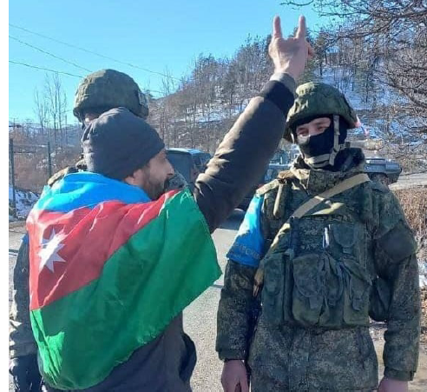The closure of the road and prohibition of the passage of the population of Nagorno-Karabakh through the corridor is an obvious act of discrimination against Armenians as an ethnic group.

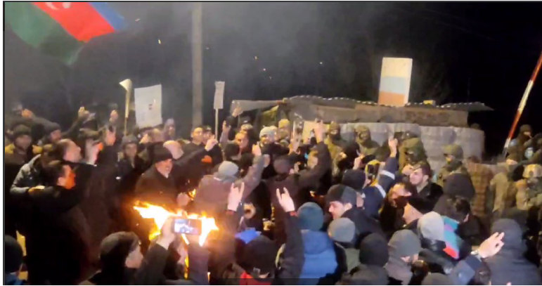Video recordings and photographs from the area reveal that the alleged “eco protestors” in fact pursue other goals. Those “eco-protestors” have been photographed displaying the hand gesture of the Grey Wolves, an ultranationalist organization widely known and condemned for anti-Armenian violence and hate speech. They have been responsible for acts of violence, including murder, targeting leftists, communists, Kurds, Armenians and other minority groups in Turkey. Some killings by Grey Wolves members were later revealed to have taken place in cooperation with the National Intelligence Organisation *(Turkish: MIT*)[26]. Below are the pictures of the ‘eco-activists’ showing the sign of grey wolves:

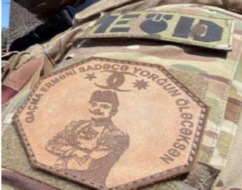Mr. Fuad Salahov, one of the “eco-activists”, posted on his Facebook a photograph of a patch depicting the notorious Ottoman genocidaire Enver Pasha with the inscription “Armenian, don’t run! You’ll die anyway, just exhausted”[27]:

There is evidence that the Government of Azerbaijan arranged the alleged “protests”. This evidence is proved by the fact that Azerbaijani citizens can enter the region only after receiving special permission from the Government,[28] meaning that the Government has granted all of the “eco activists” such permission. By contrast, Azerbaijan has prohibited independent journalists from accessing the alleged “protests”[29]. In addition, it has been reported that the Government provided the “eco activists” with tents to maintain their round-the-clock blockade[30].

Furthermore, not long after the closure of the road, Azerbaijani special forces were deployed alongside Shushi, near the place, where so called activists blocked the road[31]. This is a clear manifestation of threat, as they were deployed on the days when in Stepanakert mass rallies took place on the occasion of the blockade of the road.

As an additional proof of the actions of so-called “eco activists” to be attributed to the state of Azerbaijan as such, is the statement of Ilham Aliyev, who, as a head of a country, speaks on behalf of it. On 10 January the President of Azerbaijan in his interview with local media channels in relation to Armenians of Nagorno-Karabakh stated that: “Whoever does not want to become a citizen of our country, the road is not closed, they can leave. Nobody will interfere. They can leave in the cargo compartment of peacekeepers’ trucks, on buses. The road is open”[32]. These words directly show the intention of the authorities to implement the policy of ethnic cleansing in Nagorno-Karabakh and create such conditions for Armenians for them to leave their homeland.

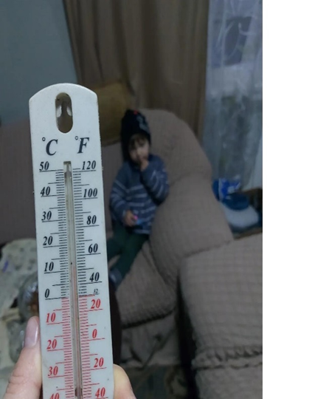On 13 December 2022, Azerbaijan cut off the supply of natural gas coming to Nagorno-Karabakh without any advance warning, leaving homes, businesses, hospitals, and schools without heat in the midst of a freezing winter. Medical facilities had to suspend scheduled surgeries to save energy and medicine. All schools in Nagorno-Karabakh that use natural gas for heating were shut down. The streets of the settlements emptied, with local gas stations supplying fuel only to ambulances, public buses, and other authorised vehicles. The educational facilities were closed because of the lack of the heating. The gas supply was restored on 16 December. It was the second time that Azerbaijanis during harsh winter conditions when gas as a method of heating is of critical necessity cut off the supplies of the gas. Earlier in 2022, in March under the guise of repair works of a gas pipeline (transferring gas from Armenia to NK, which crosses regions occupied by Azerbaijan during the 44-day war of 2020) which had allegedly exploded, the Azerbaijani side installed a valve on the pipeline, with the intention of turning it off at any given time. After the alleged repair works, the Azerbaijani side disrupted the supply of natural gas[33]. However, the restoration of gas supplies did not last long, as on 17 January 2023 at 13:00 “Artsakhgaz” announced about the lack of gas supply due to the closure of the pipeline coming from Armenia [34].

After few hours, at around 18:00 the supply was restored, however, as a new method of interrogation, it lasted for a couple of hours, as the Azerbaijani side cut the supply again at around 22:00 on the same day. ‘’It seems they play with our minds’’, said one of the residents of Nagorno-Karabakh [35]. This method or tactics of Azerbaijan goes beyond the ecological protests, as together with the closure of the road, blocking the gas supply, can be deemed as another act of siege of Nagorno-Karabakh and Armenians based on their ethnic origin**.**

One of the NK residents showed in the picture that there is only 11 degrees of Celsius in his house in January.

Consequently, all the educational establishments are now closed because of the lack of heating, moreover, even the state structures announced among the employees not to come to the office for an indefinite period as there is lack of heating and the authorities need to save electricity because of a very limited and exhausting resources[36].

As was mentioned in the chronology part of the report, due to the damage caused to the electricity high voltage line coming from Armenia and Azerbaijan’s refusal to let Armenians visit the damaged area, which is in the territory under the latter’s control, the population of Nagorno-Karabakh is deprived of regular electricity in the harsh winter conditions and experiences rolling blackouts of 4 hours daily, from 21 January of 6 hours causing problems to functioning of hospitals, house of elderlies, etc. A proven manifestation of discrimination by Azerbaijan.

Meanwhile, under the ICERD, Azerbaijan undertook an obligation *to engage in no act or practice of racial discrimination against persons, groups of persons or institutions and to ensure that all public authorities and public institutions, national and local, shall act in conformity with this obligation and to prohibit and to eliminate racial discrimination in all its forms and to guarantee the right of everyone, without distinction as to race, colour, or national or ethnic origin, to equality before the law*.

The UDHR confirms the prohibition of discrimination in its Article 7, *all are equal before the law and are entitled without any discrimination to equal protection of the law. All are entitled to equal protection against any discrimination in violation of this Declaration and against any incitement to such discrimination.* The same was reiterated in ICCPR, according to Article 26, *all persons are equal before the law and are entitled without any discrimination to the equal protection of the law. In this respect, the law shall prohibit any discrimination and guarantee to all* *persons equal and effective protection* *against discrimination on any ground such as race, colour, sex, language, religion, political or other opinion, national or social origin, property, birth or other status.*

The prohibition of discrimination is reinforced on a regional level, according to Article 14 of the ECHR*, the enjoyment of the rights and freedoms set forth in the Convention shall be secured without discrimination on any ground such as sex, race, colour, language, religion, political or other opinion, national or social origin, association with a national minority, property, birth or other status*. It was reiterated through Protocol No 12 of the Convention.

### **Right of Everyone to an Adequate Standard of Living for Himself and his Family, including Adequate Food, Clothing and Housing, and to the Continuous Improvement of Living Conditions**

As of 18 January, Azerbaijan deprived the population of Nagorno-Karabakh of the following basic conditions of life, which are part of the adequate standard of living, without even mentioning the improvement of living conditions:

1. **Gas supply** was cut for 4 times, on 18 January evening the supply was interrupted again and was not restored until 20 January with only partial flow. However, on 21 January evening it was fully suspended again. Most of the population uses gas for heating purposes as well as for their private as well as public vehicles to move within and outside the city or realise their right to education, when commuting to educational institutions, or the right to work, when using private and public vehicles for reach workplaces.
2. **Electricity supplies**. On 9 January, the high voltage line was damaged in the area under control of Azerbaijan in Lachin corridor under unknown circumstances. Up until now, Azerbaijani side refuses to let Armenians to do repair works and restore regular electricity coming from Armenia. Nagorno-Karabakh currently relies only on local resources which is 57 % of the total power used by population. Therefore, at first 2 hours and then 4 hours of daily rolling blackouts were introduced by the authorities to deal with the scarcity of electricity, the length of blackouts from 21 January becomes 6 hours.
3. **Internet connection**. On 12 January the internet connection was lost in Nagorno-Karabakh, because of damage to the internet cable. According to the local internet provider, “Karabakh Telecom” CJSC[37], the damage of the cable was exactly at the location where the alleged “eco- activists” have blocked the Lachin corridor. The cable internet was cut for 24 hours, and only mobile communication was working with interruptions. The technical specialists of "Karabakh Telecom" managed to go to the place of the accident and carry out appropriate work on the spot to restore the damaged part of the cable only after the mediation of Russian Peacekeepers.
4. 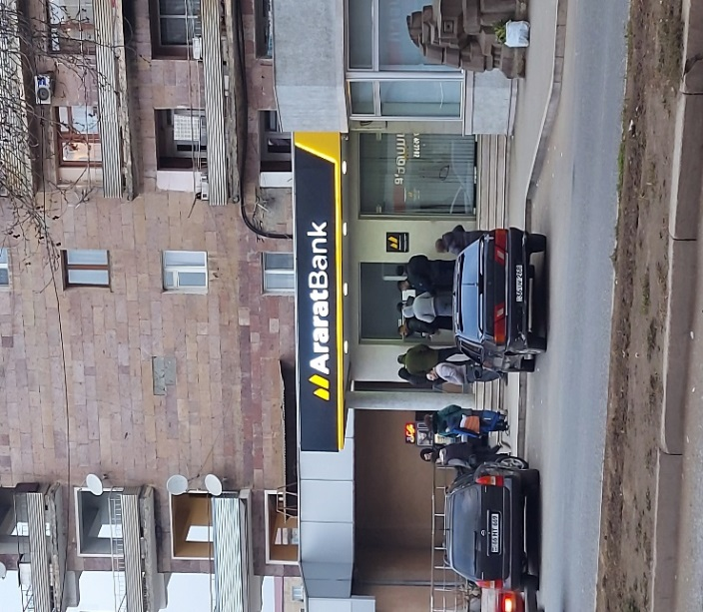**Scarcity of cash**. On 11 January, the authorities in Nagorno-Karabakh had to restrict the withdrawal amount of cash to 50.000 AMDs (around 127 USD) daily. The ATMs currently work with interruptions and population either stands in long lines in front of the ATM or in front of the banks operating in Nagorno-Karabakh.

People standing in a queue in front of one of the few functional ATMs in Stepanakert

1. **Critical situation in private sector/ many entrepreneurs experience bankruptcy.** Due to the difficult economic situation, at least 3,400 people lost their jobs and source of income, Artsakh Information Headquarters reports. 726 business entities (17.7% of the total) suspended their activities due to the impossibility of working because of the closure of the road[38]**.**
2. A picture containing engineering drawing

   Description automatically generated**Right to Adequate Food.** Nagorno-Karabakh In majority of instances relies on the supply of foodstuffs from Armenia to satisfy its local demand. According to information available through fact-finding activities of the team, daily 400 tons of food items used to be delivered to Nagorno-Karabakh. This means that on 38th day of the blocking of the road, around 15200 tons of food has been prevented to enter the territory of Nagorno-Karabakh.

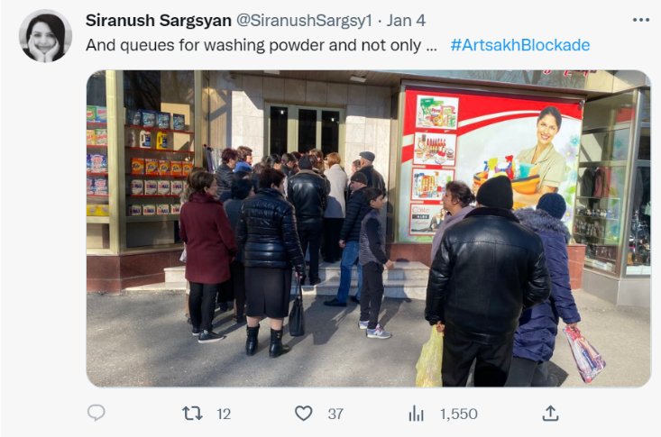As of 38th day of the siege, the supplies in local supermarkets and stores, including Stepanakert’s central market have been running extremely low. Vegetables, fruits, and berries completely disappeared from the stock; there is scarcity of sugar, buckwheat, lentils, flour, grain, oil, rice, and eggs in Stepanakert. Population stands in long queues for hours in cold weather conditions to buy basic food, while families with toddlers sometimes are not even able to reach the shop and stand long hours in the lines, while people with toddlers or elderlies do not event manage to reach the shop and stand in long queues for hours. A mother of 7 months old shares that she cannot find hygiene items such as pampers for her toddler; the road was closed so unexpectedly and for so long that she couldn’t even imagine the city would be out of the basic things such as hygiene items or basic foodstuffs [39] . To coordinate the situation, the authorities introduced a coupon system for basic food items, the system enters into force as of 20 January. The coupon/voucher system applies to the most basic foodstuffs such as pasta, rice, buckwheat, sugar, and sunflower oil. Residents will be allowed to purchase only 1 kilogram of each of these dry products and 1 litre of sunflower oil per month[40].

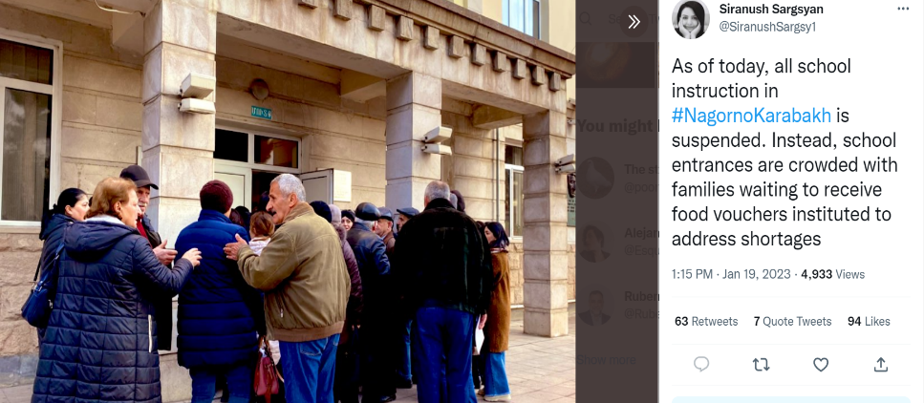The scarcity of available flour led to the situation when bakeries are struggling with the production of bread to supply the market.[41] The domestic production of dairy products is at minimum level, since the imports of feed and other necessities for small and large cattle has been stopped because of the siege[42].

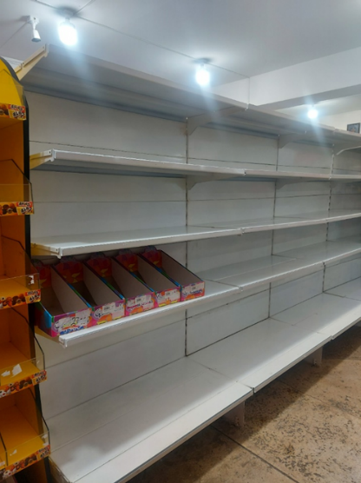The UDHR in its Article 25 clearly states that *everyone has the right to a standard of living adequate for the health and well-being of himself and of his family, including food, clothing, housing and medical care and necessary social services, and the right to security in the event of unemployment, sickness, disability, widowhood, old age or other lack of livelihood in circumstances beyond his control, thus confirming the essential nature of the right to food.*

Additionally, same clause can be found in article 11 of the International Covenant on Economic, Social and Cultural Rights (ICESCR). Moreover, it reaffirms that more immediate and urgent steps may be needed to ensure *“the fundamental right to freedom from hunger and malnutrition*”.

Empty shelves of the local supermarkets in Stepanakert. Picture is taken by our fact-finding team.

The Committee on Economic, Social and Cultural Rights has issued several General Comments explaining the components of this right including the right to adequate housing (General Comments 4 and 7), the right to food (General Comment 12), the right to water (General Comment 15) as well as the right to social security (General Comment 19). Through these General Comments, the Committee elaborated on which criteria are to be met to fulfil the rights to food and water and provides the single most comprehensive interpretation of these rights under international law [43]. According to General Comment 12, the core content of the right to adequate food includes the following elements:

*a) Availability of food: In a quantity and quality sufficient to satisfy the dietary needs of individuals. Dietary needs implies that the diet contains a mix of nutrients for physical and mental growth, development and maintenance, and physical activity that are in compliance with human physiological needs at all stages throughout the life cycle and according to gender and occupation. Measures may therefore need to be taken to maintain, adapt or strengthen dietary diversity and appropriate consumption and feeding patterns, including breast-feeding, while ensuring that changes in availability and access to food supply at the very least do not negatively affect dietary composition and intake.*

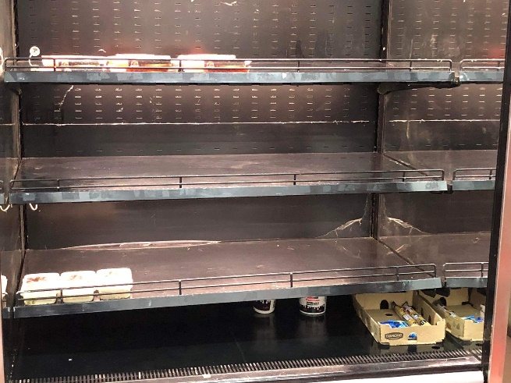The actions undertaken by Azerbaijani Government-supported so-called “eco activists” intentionallycreate conditions which deprive population, especially vulnerable categories of people as children, elderly, feeding mothers and pregnant women from the necessary food and care.

The right to an adequate standard of living is included in several other human rights treaties. Under Article 27 Convention on the Rights of the Child (CRC), “States Parties recognise the right of every child to a standard of living adequate for the child’s physical, mental, spiritual, moral and social development”. Under Article 14 of Convention on the Elimination of All Forms of Discrimination Against Women (CEDAW), “States Parties shall take all appropriate measures to eliminate discrimination against women in rural areas [...] to ensure [...] the right [...] to enjoy adequate living conditions, particularly in relation to housing, sanitation, electricity and water supply, transport and communications [....]”. The ICERD recognises the right of everyone, without distinction as to race, colour, or national or ethnic origin, to enjoy, inter alia, the right to housing, and the right to social security and social services. Article 28 of Convention on the Rights of Persons with Disabilities (CRPD) sets out the right to an adequate standard of living and social protection. Azerbaijan has ratified all these treaties [44].

### **Right to Medical Care**

According to the data available from fact-finding interviews in the hospitals, as of 18 January 10 children remain in the neonatal and intensive care units of the children's hospital; 9 adult patients remain in the intensive care unit, 4 of them in critical condition, as of 17 January 142 children were born during the blockade of the road; 430 citizens continue to be deprived of the opportunity to receive necessary medical treatment due to suspension of planned surgeries in all medical facilities of Nagorno-Karabakh[45].

Only due to mediation efforts of ICRC, as of 18 January 34 patients have been transported from NK to Armenia with the escort of the ICRC vehicles to receive appropriate treatment. One of the patients in a critical condition were not able to wait for the opportunity to be transferred to a medical facilities in Armenia, and died on the 9th day of the closure of the road [46] .

Basic medication is not available in the pharmacies, or they are given with a small quota so that they would be enough for everyone [47] .

The hygiene items, such as pads or pampers for the children and women are fully out of stock both in pharmacies and supermarkets.

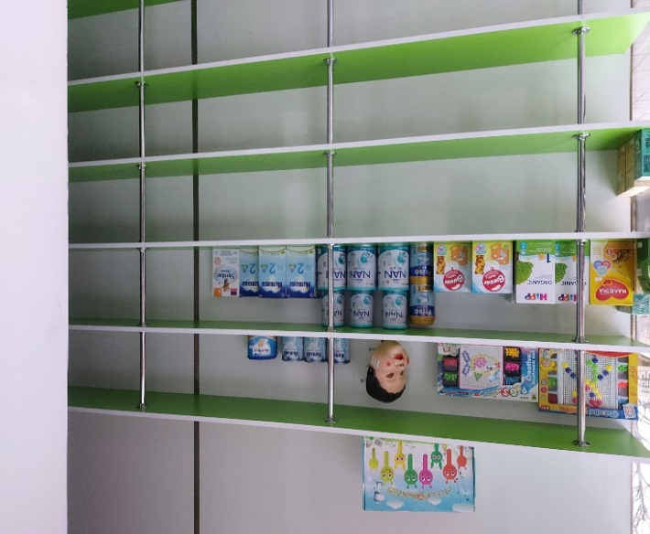Only through mediation efforts of ICRC, 4 trucks with essential medication, diapers for toddlers were escorted to Stepanakert providing safe passage to medical consignments. However, 4 trucks for the NK population of 120 thousand people are not enough, taken the fact of deprivation of regular daily deliveries for already more than a month.

As an essential human right which NK population is deprived of, Article 25 of the Universal Declaration of Human Rights mentioning right to health within the adequate standard of living, ICSECR, in its Article 12 states that:

*1. The States Parties to the Covenant recognize the right of everyone to the enjoyment of the highest attainable standard of physical and mental health.*

*2. The steps to be taken by the States Parties to the Covenant to achieve the full realization of this right shall include those necessary for, inter alia, (d) The creation of conditions which would assure to all medical service and medical attention in the event of sickness.*

The Committee on Economic, Social and Cultural Rights' (the "CESCR") authoritative interpretation of the ICESCR, General Comment 14: The Right to the Highest Attainable Standard of Health (the "GC 14") accordingly clarifies that the right "is not to be understood as a right to be healthy."' It is instead a set of freedoms and entitlements to goods and services,' namely those that are "necessary for the realization of the highest attainable standard of health." More precisely, it "must be understood as a right to the enjoyment of a variety of facilities, goods, services, and conditions necessary for the realization of the highest attainable standard of health"[48].

The right to health is reaffirmed in various international legal instruments, which Azerbaijan is party of, thus undertook obligations to respect them. Some of those instruments are of general application while others address the human rights of specific groups, such as women or children.

International human rights treaties recognizing the right to health are

• The 1965 International Convention on the Elimination of All Forms of Racial Discrimination: art. 5 (e) (iv)

• The 1966 International Covenant on Economic, Social and Cultural Rights: art. 12

• The 1979 Convention on the Elimination of All Forms of Discrimination against Women: arts. 11 (1) (f), 12 and 14 (2) (b)

• The 1989 Convention on the Rights of the Child: art. 24

• The 2006 Convention on the Rights of Persons with Disabilities: art. 25.

**Rights of the Child**

According to the information gathered, as of 16 January, 270 children, about 70 of them without their parents (they were attending the Junior Eurovision Song Contest, which was being held in Armenia, being accompanied by their teachers) were not able to pass through the Lachin corridor back home. These 270 children are now accommodated in Goris, Syunik province and in Yerevan and started attending schools in Goris and Yerevan only in January.

NK students studying in educational establishments of Armenia, who were in NK during the holidays, cannot go back to Yerevan to continue their studies. At the same time, more than 600 students and pupils in Armenia cannot return to NK and continue their studies in NK educational institutions. 10 students from Armenia who were studying in Stepanakert cannot return to their homes in Armenia. The needs of 55 children without parents and 10 adults residing in Armenia have been addressed in cooperation with and with the support of NGOs and international organizations.

The picture is from the rally organized by NK young mothers organized in front of the ICRC mission in NK demanding to help with provision of food and hygiene items and to influence to open the road

Moreover, as of 18 January 10 children remain in the neonatal and intensive care units of the children's hospital and need special medical care and medication which is scarce or absent because of the closure of the road by the so-called activists. Hygiene and medical items for toddlers are out of stock throughout Nagorno-Karabakh, making the living more difficult. During the fact-finding interviews the parents were sharing that children ask for fruits and vegetables every day and they had to explain why their usual food- source of vitamins is not available[49].

Meanwhile Article 24 of the Convention on the Rights of the Child enshrines that *States Parties recognize the right of the child to the enjoyment of the highest attainable standard of health and to facilities for the treatment of illness and rehabilitation of health. States Parties shall strive to ensure that no child is deprived of his or her right of access to such health care services. States Parties shall pursue full implementation of this right and, in particular, shall take appropriate*

*measures:*

*(a) To diminish infant and child mortality;*

*(b) To ensure the provision of necessary medical assistance and health care to all children with emphasis on the development of primary health care.*

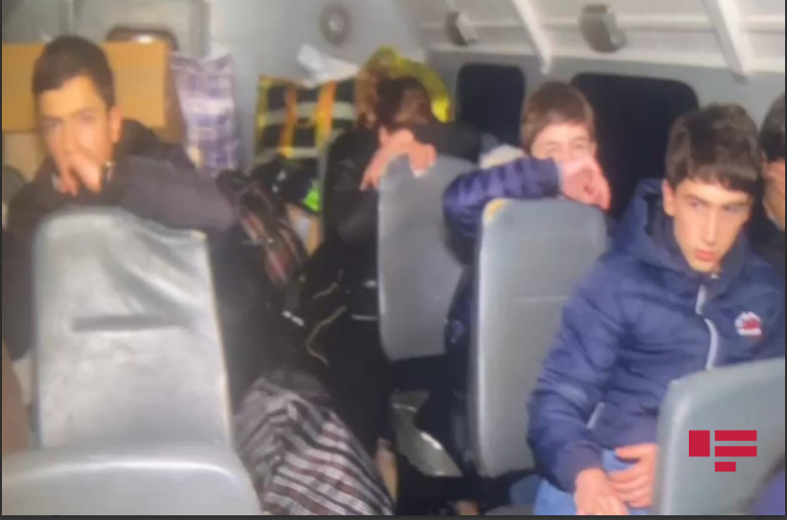Azerbaijan did not stop with violating basic rights of the children by separating them from their families and depriving from food and other necessary items but went deeper by using psychological intimidation and terror as such.

On 17 January, 19 children, separated from their parents and family for more than a month, returned home via blocked Goris-Stepanakert road. Other children staying in Goris and their accompaniers staying in Goris refused to join Russian Peacekeepers to pass through the Lachin corridor, as were scared for their lives[50]. The children were accompanied from Goris to Stepanakert by the Russian Peacekeeping Forces to provide the security of the passage. Nevertheless, the car was stopped by Azerbaijanis twice, once in Isabulagh area for one hour, where the Azerbaijani side refused to let pass the children and due to negotiation efforts of the Peacekeepers they were able to pass that part and for the second time in the area under Shushi-Karin Tak in the blocked part of the road, where the Azerbaijani government supported "eco-activists" and the journalists serving them are stationed. After stopping the cars for 30 minutes, 10-15 Azerbaijanis with face masks on, cameras in hand, and in civilian clothes approached the car. Some of them rushed into the vehicle and filmed the children in the car[51]. As a result of the provocative actions of the Azerbaijanis and the atmosphere one of the children was frightened that much that fainted. The 15 years old T.G. studying in Stepanakert music gymnasium shared about the incident to our fact-finding team [52]. Due to actions undertaken by Russian Peacekeepers, the Azerbaijanis were removed from the car, and the vehicle continued its journey. Then, while passing through the blocked section of the road, Azerbaijanis demonstratively shouted in the direction of the vehicles transporting the children by frightening the children and putting additional psychological pressure, given the fact that the children were waiting for reunification with parents for more than a month.

Photo of the children taken by journalists of apa.az news web site and published on 17 January

According to Article 16 of the Convention on the Rights of the Child, *No child shall be subjected to arbitrary or unlawful interference with his or her privacy, family, home or correspondence, nor to unlawful attacks on his or her honour and reputation. The child has the right to the protection of the law against such interference or attacks*. Meanwhile, by such acts where journalists and around 15 people with masks enter the car and take videos and photos of them manifestly violate their rights and well-being.

Moreover, according to Article 19 of the Convention, *States Parties shall take all appropriate legislative,* *administrative, social and educational measures to protect the child from all forms of physical or mental violence, injury or abuse, neglect or negligent treatment*.

### **Right to Education**

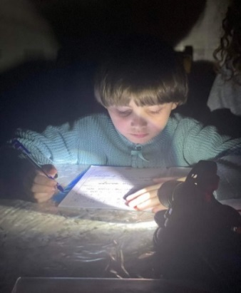Due to the gas supply shortages from 13-16 December as well as from 18 January onwards educational establishments in Nagorno-Karabakh were closed because of the harsh weather conditions and lack of heating, thus the disruption of education process was experienced since the first days of the siege of NK. Currently 117 schools have been closed and almost 20,000 children are deprived of the opportunity to receive education [53].

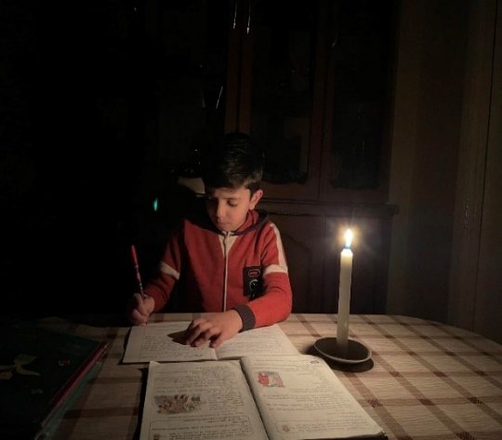Moreover, because of the electricity cut and rolling blackouts introduced out of scarcity of the electricity of local resources and power plants, children had to study and do their homework under the candles and poor light.

Kindergartens, pre-schools, and groups of primary schools and schools working with extended hours as of 9 January stopped operating because of the deficiency of food items resulting in 41 kindergartens, 56 pre-schools, and 20 all-day education institutions have been forced to suspend functioning. Consequently, 6828 children of kindergartens, pre-schools and groups of primary schools have been deprived of the opportunity to receive care and education, while from 18 January their number increased immensely reaching to all schools and educational establishments.

Students are deprived of participation in educational events in Armenia and abroad[54]. High school students are not able to participate in entrance exams if they want to study in Armenia [55].

More than 50 teachers are unable to return to NK and continue their official duties because of the closure of the road. During the fact-finding interview, one of the teachers shared that due to her health problems she travelled to Yerevan and was supposed to return on the day of closure of the road and now she had to stay in a hotel and cannot conduct classes and due that fact, the education process in more than 4 grades was disrupted [56].

As for the children that travelled to Yerevan to participate in Eurovision song contest and were stuck on the road on 12 December because of the closure of the road by so-called “eco-activists”, they had to stay in Goris for more than a month, while for the majority of the period they could not attend a school and were basically deprived of their right to education. Only in the last week before their return they were able to go to school in Goris [57].

Coming back to the international legislative framework on the right to education, which is gravely violated by Azerbaijan, Universal Declaration of Human Rights states in its Article 26 that everyone has the right to education. Moreover, ICSECR Article 13 enshrines that the States Parties to the present Covenant recognise the right to education as such.

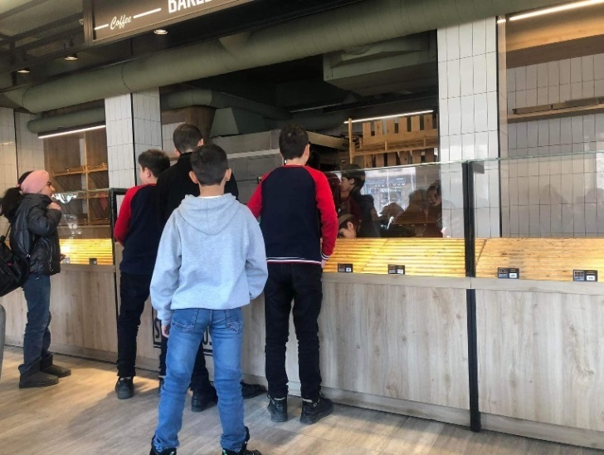Convention on the Elimination of All Forms of Racial Discrimination, in its Article 5 also refers to the right to education, in compliance with the fundamental obligations, notably related to the enjoyment of such rights as *(e) Economic, social and cultural rights, in particular: (v) The right to education and training.*

Children standing in a queue during the study break to get some food in a school cafeteria which is usually full of food. Now it is empty.

The mentioned right along with others will be additionally discussed from the perspective of International Humanitarian Law.

### **The Right to Family and Private Life**

The rights of the child are directly correlated with the violation of the right to family and private life. According to Article 8 of European Convention on Human Rights and Fundamental Freedoms, *everyone has the right to respect for his private and family life, his home and his correspondence*.

Article 17(1) of the ICCPR provides: “No one shall be subjected to arbitrary or unlawful interference with his privacy, family, home or correspondence, nor to unlawful attacks on his honour and reputation.” Article 17(2) provides: “Everyone has the right to protection of the law against such interference or attacks.”

Meanwhile separation of the child from his/her family by the closure of the only road leading to home and interrogation of the children in the car with cameras violating their private life are manifest violation by Azerbaijan. About 50 children were left without parental care in NK. Among them are minor children who are left alone at home.[58] In the Msmna village of NK, two youths aged 11 and 13 were left without a guardian, because their parents had left for Armenia before the road was closed to participate in the funeral of a relative and have not been able to return to this day[59]. The mother of the 8-month-old child left Stepanakert for a day in Yerevan and was able to return only after 28 days, through the mediation of the ICRC[60]. Three IDP children with eldest of 6 who lost their homes after 2020 war and residing in Metsamor city in Armenia were left without parental care for more than a month, as their parents with their sibling of 7 months old left for Nagorno-Karabakh to participate in a funeral and were not able to return. The children now live with the grandmother of 65 years old, who is disabled of 2nd group and needs help herself in taking care of the children, that Is why their 14 years old cousin had to skip school and take care of the children [61]. Due to the mediation efforts of ICRC only after 39 days, the parents were able to reunite with their children in Metsamor.

# **3. Siege of Nagorno-Karabakh under International Humanitarian Law**

The act of closure of the only road connecting Nagorno-Karabakh to Armenia and outside world is a pure act of siege under International Humanitarian Law, which has negative consequences for the civilian population, leading to starvation, which is prohibited under IHL. 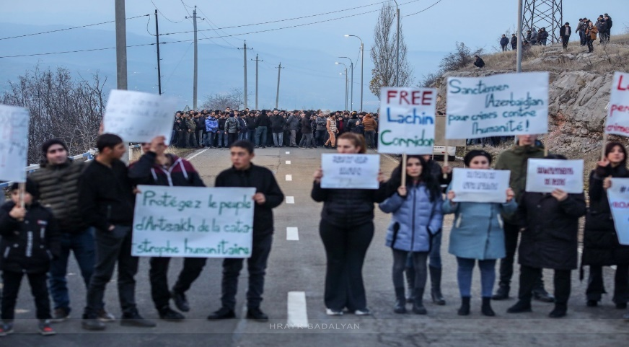

The essence of a siege lies in the encirclement of a defended area and the subsequent isolation of the enemy forces by cutting of their channels of supply and reinforcement with a view of inducing the enemy into submission by means of starvation[62]. However, in case of the present siege the only victims of the siege are civilian population and its vulnerable groups.

The very first rule in customary IHL states about sparing civilian population from combatant and not to inflict suffering to civilians [63]. Thus, although Azerbaijan is not signatory of two additional protocols to Geneva Conventions, the very customary law emphasises the necessity not to direct attacks against civilian population, whereas in this case the population as a whole- 120 thousand people are under siege, hence under the threat of starvation. Rule 53 of the Customary IHL states that starvation of civilian population as a method of warfare is prohibited. This as a reflective of customary international humanitarian law was reaffirmed in Additional Protocol 1 to the Geneva Conventions. Article 54(1) of the 1977 Additional Protocol I provides: “*Starvation of civilians as a method of warfare is prohibited*.” [64] Thus, acts of Azerbaijanis, deliberately creating such conditions as to causing starvation by cutting gas, electricity supplies available as well as banning regular access of foodstuffs can be perceived as an act aimed at starvation and intimidation of the civilian population as such.

Picture taken when NK residents marched towards “eco activists” to demand to open the road, but were stopped by Russian Peacekeepers 62

**Most affected-vulnerable groups**

Additionally, Rule 135 of the 2005 ICRC customary IHL study prescribes that “*children affected by armed conflict are entitled to special respect and protection”* in international and non-international armed conflicts, while the actions undertaken by Azerbaijanis in the evening of 17 January, stopping the car with children, taking the pictures and causing fainting one of the child on the way to reunite with their families is clear violation of the rule. Geneva Convention IV relative to the Protection of Civilian Persons in Time of War in its Article 23, first paragraph, of the 1949 Geneva Convention IV provides: *“Each High Contracting Party shall … permit the free passage of all consignments of essential foodstuffs, clothing and tonics intended for children under fifteen, …”*

Customary IHL emphasises the basic rights of the children during the armed conflict, including:

•access to education, food and health care (Rules 55 and 131);

•reunification of unaccompanied children with their families (Rules 105 and 131)

The basic rights to be respected during the armed conflict include Access for Humanitarian Relief to Civilians in Need. Rule 55 states that the parties to the conflict must allow and facilitate rapid and unimpeded passage of humanitarian relief for civilians in need, which is impartial in character and conducted without any adverse distinction, subject to their right of control. Meanwhile ICRC was allowed to pass through the corridor only more than a week after the siege. About 400 tons of essential goods, including grain, flour, vegetables, fruits, economic goods, etc., are imported to Nagorno-Karabakh from Armenia daily. *On 25 December, ICRC transferred 10 tons of humanitarian aid, which compared to the daily deliveries before the siege are the small part of the necessary and essential commodities and food items. The ICRC has delivered food parcels to 9 medical facilities, a boarding school for children from vulnerable families, and an institution supporting around 300 elderly persons living in extreme poverty. However, one time provision of parcels within 38 days is not sufficient to survive in the critical conditions imposed by Azerbaijanis.*

To continue with the right to respect of family life and privacy in human rights law, IHL adds and elaborates further, customary Rule 105 states that Family life must be respected as far as possible. Article 27, first paragraph of the 1949 Geneva Convention IV provides: “Protected persons are entitled, in all circumstances, to respect for their … family rights” [65] . According to the information gathered by our fact-finding team, 270 children, about 70 of them without their parents (they were attending the Junior Eurovision Song Contest which was being held in Armenia, being accompanied by their teachers) were not able to pass through the Lachin corridor back home. These 270 children have been accommodated in Goris, Syunik province and in Yerevan and started attending schools in Goris and Yerevan. Only few of them were able to return on 17 January being subjected to psychological violence by Azerbaijanis stopping on the road near Shushi-Karin Tak part of the corridor mentioned previously. As was mentioned previously, the mother of the 8-month-old child left Stepanakert for a day in Yerevan and was able to return only after 28 days, through the mediation of the ICRC.

Under customary humanitarian law Rule 138, the elderly, disabled and infirm affected by armed conflict are entitled to special respect and protection, while the most vulnerable people in the sieged Nagorno-Karabakh are the ones in nursing homes, elderlies living alone as well as disabled people needing special care and medication, but being deprived of their purchase on a regular basis[66].

By the siege of Nagorno-Karabakh given the proportion of the number of armed forces and general civilian population, it becomes immediately apparent that the principle of proportionality is gravely violated and there is no such military necessity after armed hostilities of 2020 when more than 70 percent of the territory of NK became under control of Azerbaijan and given the trilateral ceasefire statement from 9 November 2020, where Azerbaijan itself undertook a responsibility to provide security of Lachin corridor and safe passage of civilians.

# **CALL TO THE INTERNATIONAL COMMUNITY**

**Along with this report presenting the critical situation of our people, we, the non-governmental organisations (NGOs) of Nagorno-Karabakh urge the members of international community to take the responsibility and**

**To take action and use their influence and power to force Azerbaijan to open the only road linking Nagorno-Karabakh** to Armenia and outside world (Lachin Corridor), which is a life road for the inhabitants of Nagorno-Karabakh blockaded for already 44 days,

**To prevent humanitarian catastrophe** leading to irreparable consequences for the 120,000 people (population of Nagorno-Karabakh),

**To stop gross violations of human rights** of the residents of Nagorno-Karabakh by Azerbaijan, described in the present report,

**To end the sufferings (malnutrition, threat of starvation, psychological terror and intimidation, deprivation of gas and electricity, heating, right to education, etc.) of 120, 000 people**- victims of discriminatory policy and dictatorship of Azerbaijan,

**To use the channels to restore freedom of movement** **and safe passage** throughout Lachin Corridor,

**To use sanctions against the aggressor** **state Azerbaijan**, which uses every measure to ethnically cleanse the territory of Nagorno-Karabakh from its indigenous population- Armenians.

**To establish and send a fact-finding international mission, including journalists of prominent media outlets**, to record and report on the situation on the ground and provide an impartial coverage of the existential threats experienced by the Armenian people in Nagorno-Karabakh.

# **List of NGOs:**

1․ “Civic Hub” NGՕ

2. “Stepanakert Press Club” NGO

3. “Deoccupation of Hadrut” NGO

4. “Return to Qarvatchar” NGO

5. “Askeran Development Center” NGO

6. “Vector” NGO

7. “Youth Public Research Center” NGO

8. “Give Hope’’ NGO

9. “Education for Future” NGO

10. “Refugees Union for Justice” NGO

11. “Refugee Women’s Association” NGO

12. “To Do” NGO

13. “The Power of the Mind” NGO

14. ‘’Perspective’’ NGO

15. “Motherhood” NGO

16. “Return to Dizak” NGO

17. “Center for Support and Development of Women and Children” NGO

18. “Society of the Blind” NGO

19. “Yes” Educational Foundation

20․ “Return to Kashatagh” NGO

21. “For the sake of Hadrut” NGO

22. “Harmonia” Women’s NGO of Shushi

23. “Krunk” NGO for the protection of the rights of Artsakh Armenians

1. Russian Federation, Ministry of Defence, *News bulletin of the Ministry of Defense of the Russian Federation on the operations of the Russian peacekeeping forces in the area of the Nagorno-Karabakh conflict (as of December 13, 2022)* (16 January 2023)
2. Genocide Watch, *Genocide Warning: Azerbaijan and Nagorno-Karabakh* (23 September 2022), *available at*

   https://www.genocidewatch.com/single-post/genocide-warning-azerbaijan-and-nagorno-karabakh-september-

   2022
3. Genocide Watch, *Genocide Alerts* (last visited 19 December 2022), *available at*

   <https://www.genocidewatch.com/copy-of-current-genocide-watch-alert>
4. Genocide Watch, *Azerbaijan Blocks the Only Road into Nagorno-Karabakh* (14 December 2022), *available at*

   <https://www.genocidewatch.com/single-post/alert-azerbaijan-blocks-the-only-road-into-nagorno-karabakh>
5. Artsakh blockade continues for nine days: patient dies in hospital, available at <https://news.am/eng/news/735939.html>, accessed 12 January 2022
6. Thousands rally in NK demanding the Lachin corridor be opened, available at <https://jam-news.net/unity-rally-on-renaissance-square-in-nk/> , accessed on 10 January 2023
7. Official Facebook page of SOS initiative <https://www.facebook.com/annihilation.life/videos/691765449309732>
8. <https://iravaban.net/en/411277.html> (accessed on 15 January 2023)
9. Iinterview with the employee of ‘Artsakhenergo’ CJSC, 11 January 2023
10. Offical Facebook page of “Artsakhenergo” CJSC, <https://www.facebook.com/profile.php?id=100088251438925>
11. Aliyev interview with local TV, available at <https://jam-news.net/aliyev-interview-with-local-tv/> , accessed on 20 January 2023
12. Blackouts and food rationing as Karabakh blockade enters second month, available at <https://eurasianet.org/blackouts-and-food-rationing-as-karabakh-blockade-enters-second-month> (accessed on 13 January 2023)
13. "Era of peace in action": Artsakh switches to four-hour schedule of rolling outages due to Azerbaijani blockadem available at <https://arminfo.info/full_news.php?id=73950&lang=3> (accessed on 17 January 2023)
14. Artsakh schools stop functioning due to lack of heating, available at <https://mediamax.am/en/news/karabakh/50057/> (accessed on 20 January 2023)
15. Official information provided from the NK Ministry of Education, Science, Culture and Sports (19 January 2023)
16. The resolution is available at <https://www.europarl.europa.eu/doceo/document/TA-9-2023-0012_EN.html> , (accessed on 22 January 2023)
17. Announcement of 6 hours-long rolling blackouts by the NKR InfoCenter <https://www.facebook.com/ArtsakhInformation/posts/487569393559852> (accessed on 20 January 2023)
18. Announcement about gas supply interruption <https://www.facebook.com/ArtsakhInformation/posts/488263826823742> (accessed on 21 January 2023)
19. Interview with the owner of one of the vehicles, resident of Yerevan that travelled to Stepanakert and was to return home, but was stuck on the road, 17 January 2023
20. Artsakh under blockade by Azerbaijan, facing humanitarian crisis, available at <https://armenianweekly.com/2022/12/14/artsakh-under-blockade-by-azerbaijan-facing-humanitarian-crisis/> , accessed on 17 January 2023
21. Interview with the representative of the bus station, 13 January 2022
22. Fact-finding interview with a resident of Yeghtsahogh who is stuck in Stepanakert, 21 January 2023
23. Interview with a teacher in a secondary school in Stepanakert, 15 January 2023
24. 5 ICRC vehicles moved freely from Khankendi to Lachin, available at <https://apa.az/en/social/5-icrc-vehicles-moved-freely-from-khankendi-to-lachin-394206>, accessed on 20 January 2023
25. Document: Full text of the agreement between the leaders of Russia, Armenia and Azerbaijan, available at <https://www.commonspace.eu/news/document-full-text-agreement-between-leaders-russia-armenia-and-azerbaijan>, accessed on 15 January 2023
26. Who are the Grey Wolves and why is France banning them?

    France has passed a decree outlawing the far-right Grey Wolves, but Turkey has said no such organisation exists, available at <https://www.middleeasteye.net/news/grey-wolves-france> , accessed on 15 January 2023
27. Fuad Salahov’s personal Facebook page, available at <https://www.facebook.com/photo.php?fbid=3294376740819909>, accessed on 16 January 2023
28. “Can You Be Arrested Or Fined For Trespassing Demilitarized Zones?”, BBC News (10 February 2021),

    available at <https://www.bbc.com/azeri/azerbaijan-56015951>, accessed on 16 January 2023
29. “Independent Journalists Were Not Allowed To Participate in the Protest on the Shusha-Khankendi Road”, AZ Today (15 December 2022), available at <https://aztoday.az/news/204495.html> , accessed on 12 January 2023
30. Azerbaijanis again block the road to Karabakh, available at <https://eurasianet.org/azerbaijanis-again-block-the-road-to-karabakh>, accessed on 16 January 2023
31. Official Twitter Page of Azeri Times, available at <https://twitter.com/AzeriTimes/status/1607068294359519232> accessed on 14 January 2023
32. Aliyev interview with local TV, available at <https://jam-news.net/aliyev-interview-with-local-tv/>, accessed on 20 January 2023
33. The joint statement of the Human Rights Defenders of Armenia and Artsakh, available at <https://ombuds.am/en_us/site/ViewNews/2174>, accessed 14 January 2023
34. Announcement of “Artsakhenergo” CJSC , available at <https://www.facebook.com/ArtsakhInformation/posts/486058687044256>, accessed on 18 January 2023
35. Fact-finding interview with a women, resident of Stepanakert that has 2 children, 17 January 2023
36. Fact-finding interview with a civil servant, 19 January 2023
37. Interview with the employee of Karabakh Telecom, 12 January 2023
38. Because of the Blockade people lost their jobs, available at <https://www.civilnet.am/news/688971/%D5%B7%D6%80%D5%BB%D5%A1%D6%83%D5%A1%D5%AF%D5%B4%D5%A1%D5%B6-%D5%B0%D5%A5%D5%BF%D6%87%D5%A1%D5%B6%D6%84%D5%B8%D5%BE-%D5%A1%D6%80%D6%81%D5%A1%D5%AD%D5%B8%D6%82%D5%B4-3-400-%D5%B4%D5%A1%D6%80%D5%A4-%D5%AF%D5%B8%D6%80%D6%81%D6%80%D5%A5%D5%AC-%D5%A7-%D5%A1%D5%B7%D5%AD%D5%A1%D5%BF%D5%A1%D5%B6%D6%84%D5%A8-726-%D5%BF%D5%B6%D5%BF%D5%A5%D5%BD%D5%BE%D5%A1%D6%80%D5%B8%D5%B2-%D5%AF%D5%A1%D5%BD%D5%A5%D6%81%D6%80%D5%A5%D5%AC-%D5%A7-%D5%A3%D5%B8%D6%80%D5%AE%D5%B8%D6%82%D5%B6%D5%A5%D5%B8%D6%82%D5%A9%D5%B5%D5%B8%D6%82%D5%B6%D5%A8/> , accessed on 16 January 2023
39. Fact-finding interview, 19 January 2023
40. Mechanisms being developed for introduction of coupon system in Karabakh, available at <https://news.am/eng/news/738733.html> accessed on 10 January 2023
41. Interview with the representative of a bakery in Stepanakert, 18 January 2023
42. Interview with a representative of a factory producing dairy products, 17 January 2023
43. The right to an adequate standard of living, Icelandic Center of Human Rights, available at <https://www.humanrights.is/en/human-rights-education-project/human-rights-concepts-ideas-and-fora/substantive-human-rights/the-right-to-an-adequate-standard-of-living>, accessed on 15 January 2023
44. International Justice Resource Center, Azerbaijan Factsheet, available at <https://ijrcenter.org/country-factsheets/country-factsheets-europe/azerbaijan-human-rights-factsheet/>, accessed on 16 January 2023
45. Interview with the representative of republic medical hospital in Stepanakert, 14 January 2023
46. Artsakh blockade continues for nine days: patient dies in hospital, available at

    <https://news.am/eng/news/735939.html> , accessed on 12 January 2023
47. Interview with a pharmacist in Stepanakert, 14 January 2023
48. Comm. on Econ., Soc. & Cultural Rts., General Comment No. 14: The Right to the Highest Attainable Standard of Health, ¶ 8, U.N. Doc. E/C.12/2000/4 (Aug. 11, 2000) [hereinafter GC 14].
49. Interview with 3 mothers of 3, 4 and 6 years old.
50. Interview with one of the children who passed the road, 20 January 2023
51. The videos and pictures were posted among others on <https://apa.az/en/domestic-policy/26-armenians-who-remained-in-armenia-before-the-protests-were-moved-to-khankendi-photo-393984> web site, (accessed on 18 January 2023)
52. Interview with two of the children that passed through the corridor on 17 January, 20 January 2023
53. Official information provided from the NK Ministry of Education, Science, Culture and Sports (19 January 2023)
54. Interview with a person who was supposed to travel to Europe for an international sports competition, 17 January 2023
55. Interview with a child who was supposed to participate in entrance exam for an international school, but could not because of the blockade, 10 January 2023
56. Interview with a teacher staying in Yerevan because of the road closure, 11 January 202
57. Interview with one of the children, in presence of her parent.
58. Statistics Provided by the Human Rights Defender of Artsakh, 16 January 2023
59. Fact-finding interview
60. Interview, 18 January 2023
61. Interview, 18 January 2023
62. US Department of the Army, Urban Operations, Field Manual 3-06, 2006, paras 6.12–6.14; Yoram Dinstein, The Conduct of Hostilities under the Law of International Armed Conflict, 3rd ed., Cambridge University Press, Cambridge, 2016, p. 253, para. 688; Sean Watts, Under Siege: International Humanitarian Law and Security Council Practice concerning Urban Siege Operations, Counterterrorism and Humanitarian Engagement Project, Harvard Law School Project on Law and Security, May 2014, p. 3
63. Customary IHL, Jean Marie Hankaerts, Rule 1, also Article 57(2) AP I. <https://ihl-databases.icrc.org/en/customary-ihl/v1/rule1>
64. Ibid rule 53, Article 54(!) AP I
65. GC IV, also Article 46 of the 1899 Hague Regulations provides: “Family honour and rights … must be respected.” Regulations concerning the Laws and Customs of War on Land, annexed to Convention (II) with Respect to the Laws and Customs of War on Land, The Hague, 29 July 1899, Article 46, Regulations concerning the Laws and Customs of War on Land, annexed to Convention (IV) respecting the Laws and Customs of War on Land, The Hague, 18 October 1907, Article 46.
66. Articles 27, 85 and 119 of the 1949 Geneva Convention IV state in relation to the treatment of protected persons that their age should be taken into account.

    Convention (IV) relative to the Protection of Civilian Persons in Time of War, Geneva, 12 August 1949, Articles 27, 85 and 119.